Sydenham Cricket Club

Established 1885

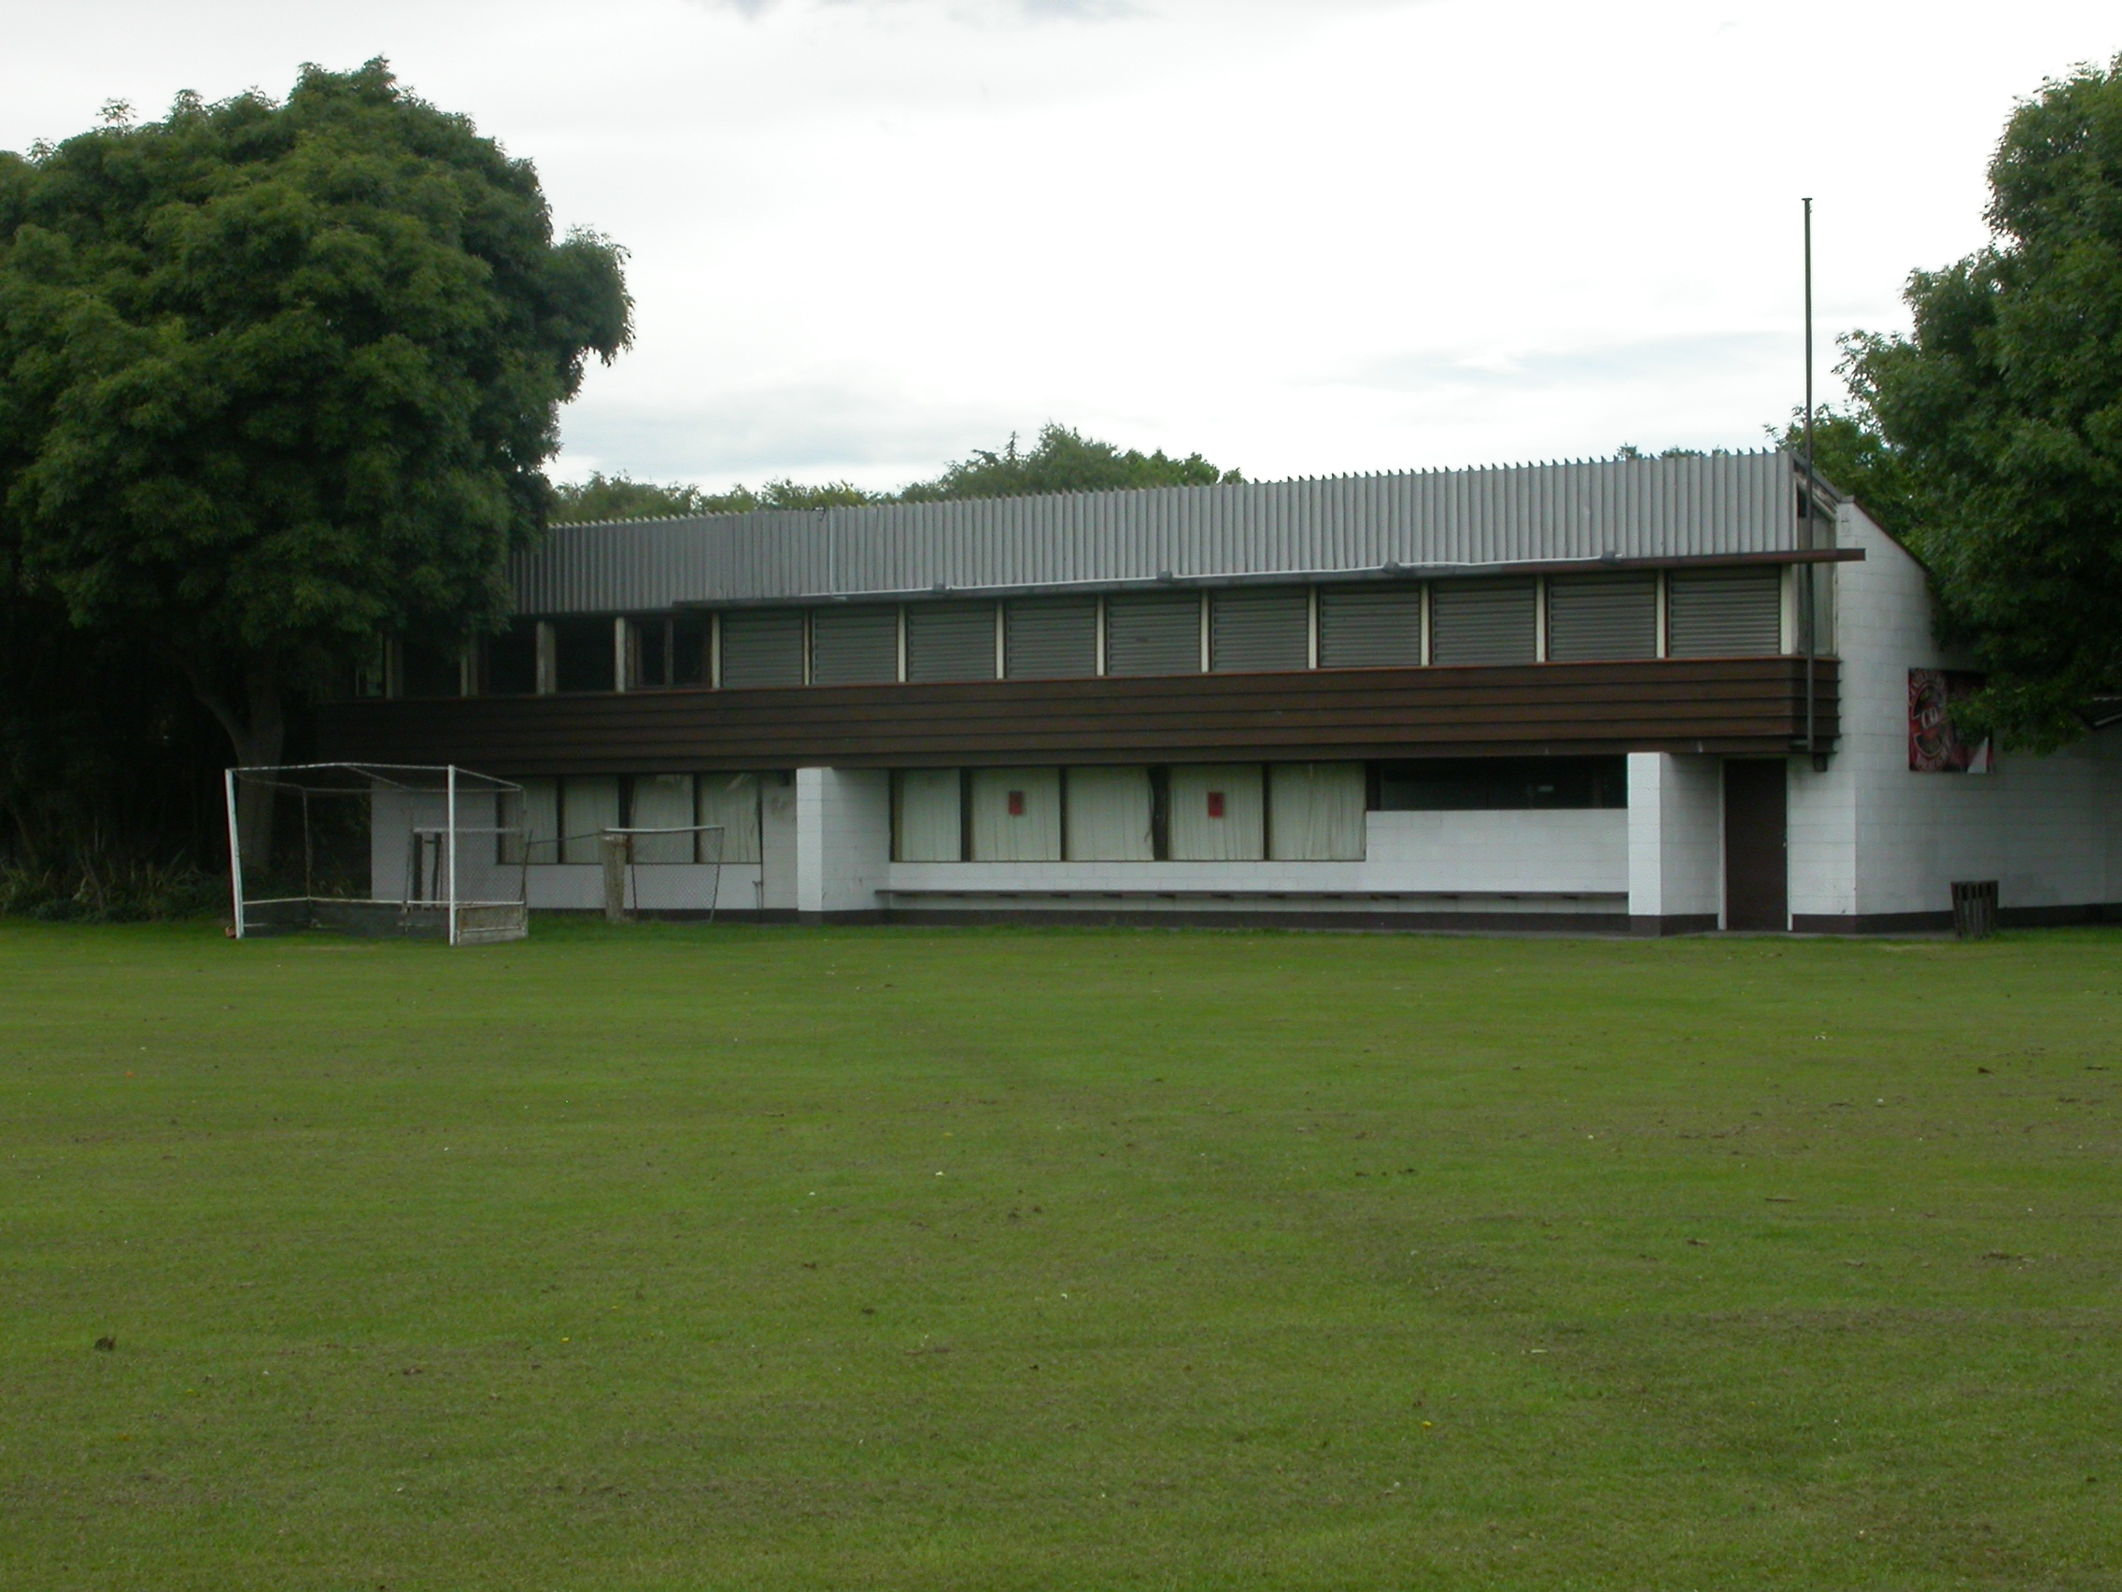

Home Ground Sydenham Park
Match pitches 3 grass match pitches
Practice pitches Grass block 3 artificial pitches
Secondary ground Bradford Park 1 grass pitch

Entries 2001-02 5 men teams 3 women teams 25 junior teams
2002-03 5 men teams 4 women teams 1 youth team 33 junior teams
2003-04 7 men teams 3 women teams 1 youth team 43 junior teams
2004-05 6 men teams 4 women teams 1 youth team 28 junior teams
2005-06 9 men teams 3 women teams 2 youth teams 30 junior teams

Grade wins last 6 years
Men 2005-06 Senior combined Third grade
Women 2003-04 First reserve grade
2005-06 Second grade

Subscriptions Adult $220
Student $110
Junior $50

Income 2004-05 Subscriptions
Gaming $75,462
Total $76,141
Expenditure Grounds $26,131
Gear
Total $78,930
Deficit $2,789
Accumulated Funds

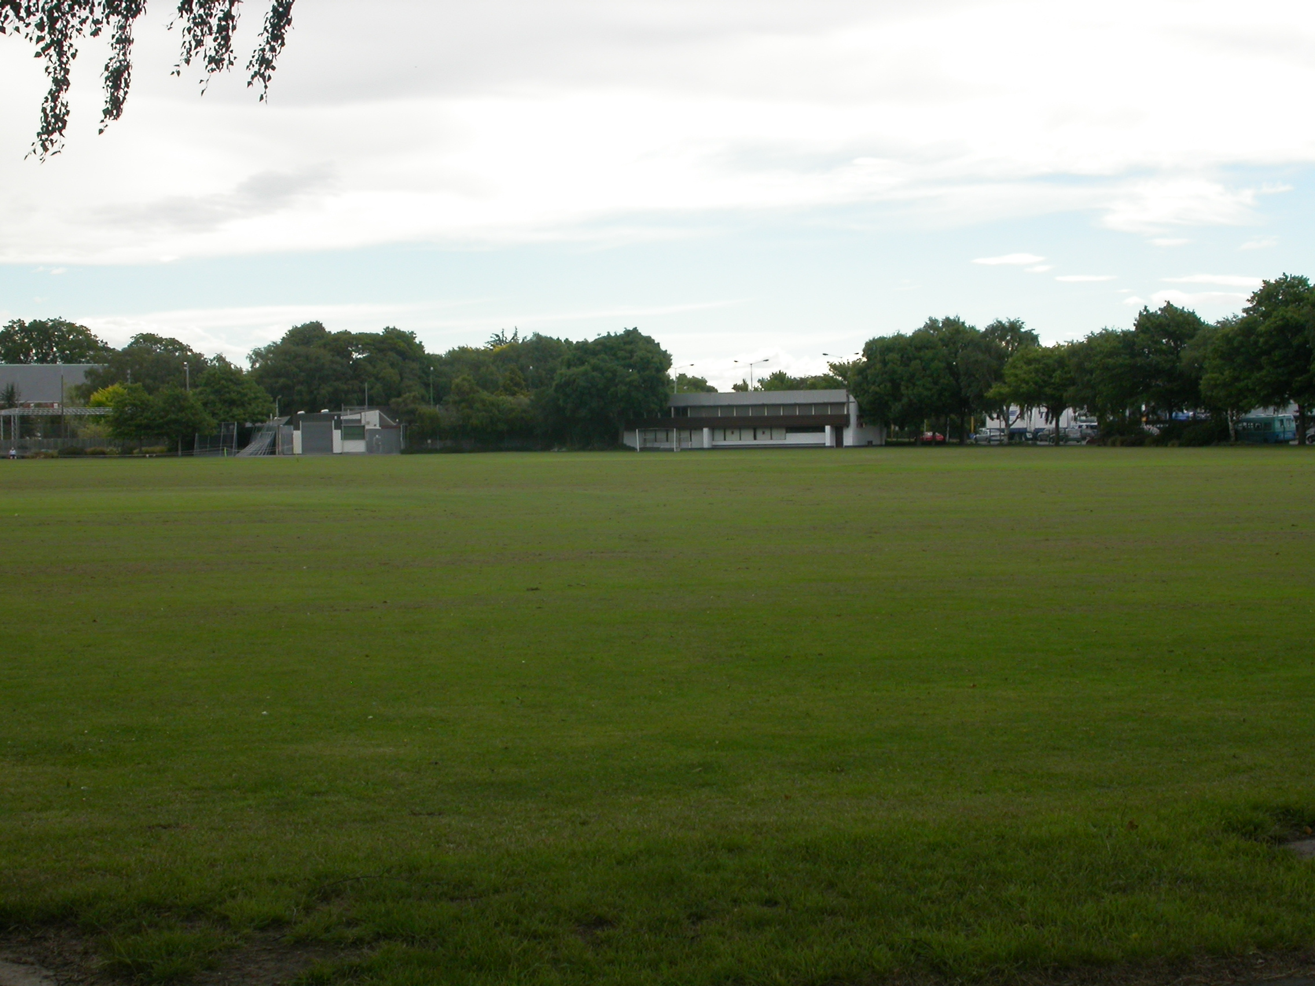

Bradford Park

